### **Project 6：Photocell Sensor**

**Description**

The photocell sensor (photoresistor) is a resistor made by the photoelectric effect of a semiconductor. It is very sensitive to ambient light, thus its resistance value vary with different light intensity. We use its features to design a circuit and generate a photoresistor sensor module. The signal end of the module is connected to the analog port of the microcontroller. When the light intensity increases, the resistance decreases, and the voltage of the analog port rises, that is, the analog value of the microcontroller also goes up. Otherwise, when the light intensity decreases, the resistance increases, and the voltage of the analog port declines. That is, the analog value of the microcontroller becomes smaller. Therefore, we can use the photoresistor sensor module to read the corresponding analog value and sense the light intensity in the environment. It is commonly applied to light measurement, control and conversion, light control circuit as well.

**Specifications：**

* Working voltage: 5V (DC)
* Interface: 4PIN interface
* Output signal: analog signal
* Weight: 2.3g

**Equipment:**

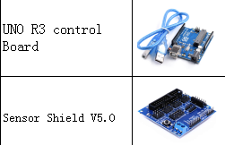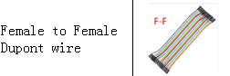

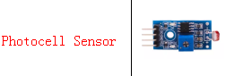

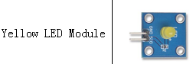

**Connection Diagram：**

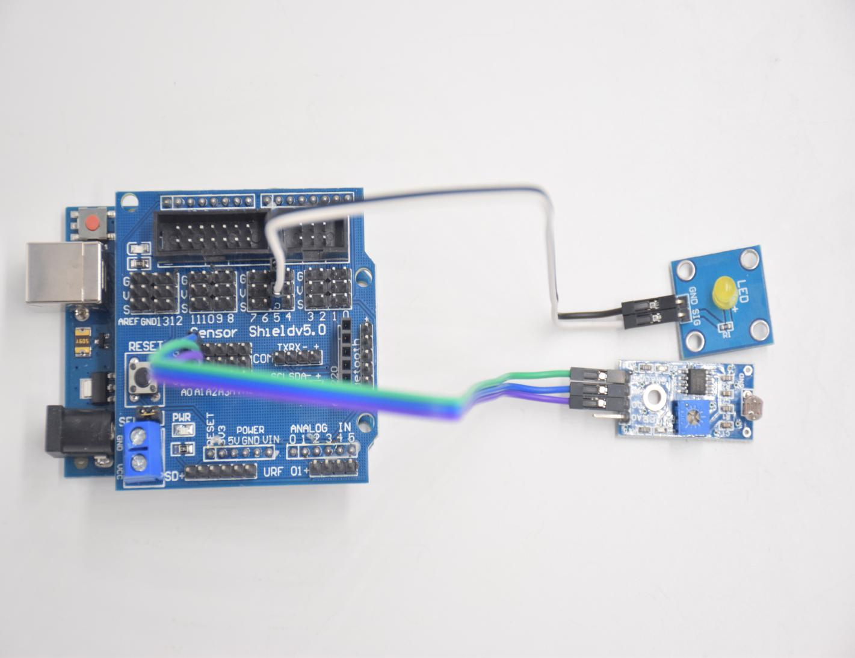

**Photosensitive LED**

**Vcc -- 5v SIG -- D5**

**Gnd -- GND GND -- GND**

**DO -- A1**

**AO -- No answer**

**Test Code：**

**int LED = 5; // Set LED pin at D5**

**int val = 0; // Read the voltage value of the photodiode**

**void setup () {**

**pinMode (LED, OUTPUT); // LED is output**

**Serial.begin (9600); // The serial port baud rate is set to 9600**

**}**

**void loop () {**

**val = analogRead (A1); // Read the voltage value of A1 Pin**

**Serial.println (val); // Serial port to view the change of voltage value**

**if (val <900)**

**{// Less than 1000, LED light is off**

**digitalWrite (LED, LOW);**

**}**

**else**

**{// Otherwise, the LED lights up**

**digitalWrite (LED, HIGH);**

**}**

**delay (10); // Delay 10ms**

**}**

**Test Result：**

LED will be on after uploading test code, point at the photocell sensor with flashlight (or the flash from cellphone), you’ll find that LED is automatically off. However, take away the flashlight, LED will be on again.

**Review** For this code string, it is simply. We read value through analog port, please attention that analog quantity doesn’t need input and output mode.Read the analog value of photocell sensor by analog port.

The analog value will gradually decreases once there is light, the value is up to 1000, this value can be chosen according to brightness you need. Select method: put the whole device in the environment where LED is off, open serial monitor to check shown value, replace 1000 with this value. Read value from serial monitor is a good way to modulate code